**BABY CLASS TOPICAL BREAK DOWN TERM II.**

LA 5b READING .

Week 1

Orientation

Week 2 Learning outcome (iii)

Reviewing jolly phonic set 1

s a t i p n

P1 Sound and write

____ _____ _____

P2/3 n _____ _____

t _____ ____

P 4/5 i ____ _____

p ____ _____

**WEEK 3**

s n ___

a p ___

p a ___

n s ___

**PD2** Read and match

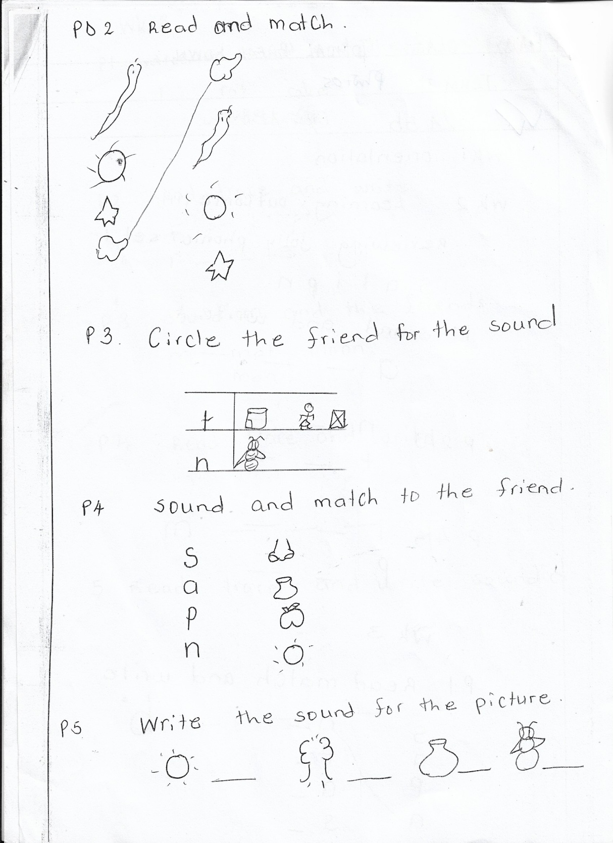

**P3**  Circle the friend for the sound.

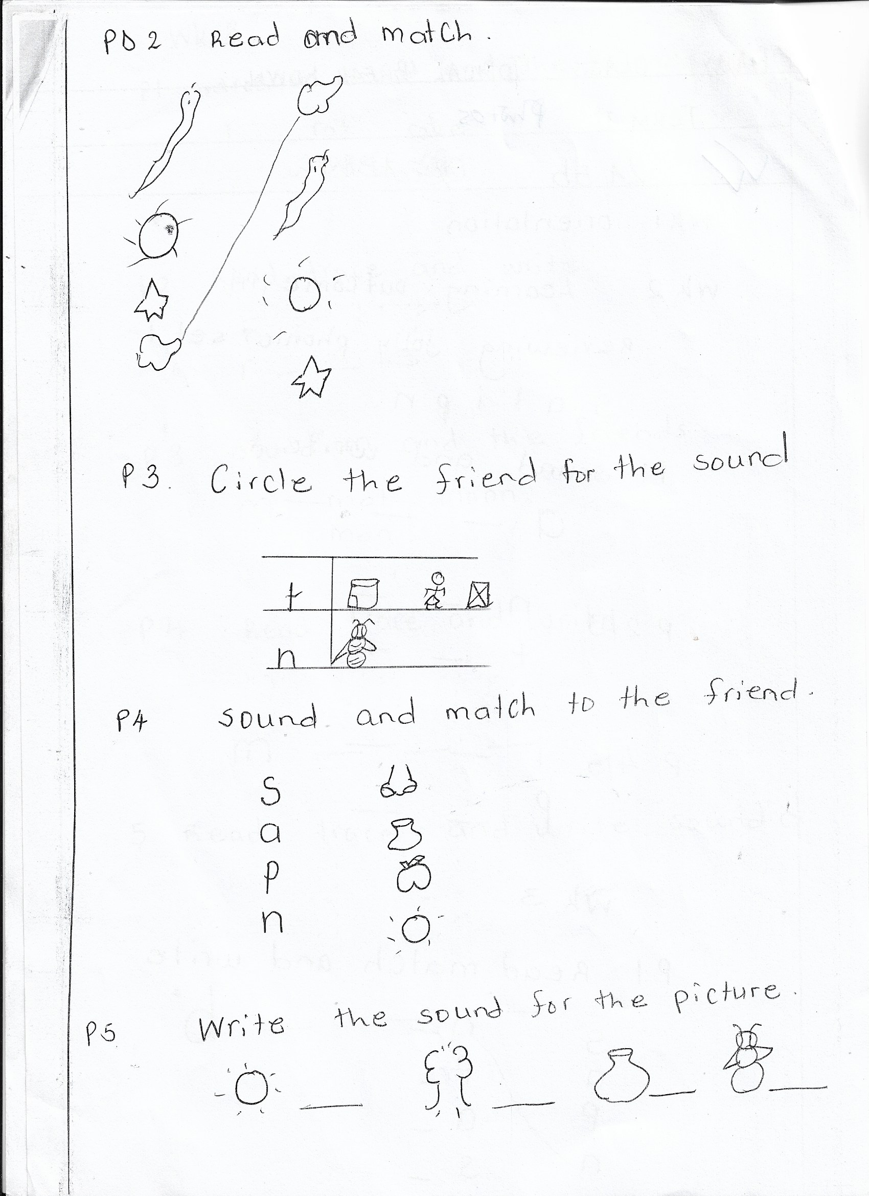

**P4** Sound and match to the friend.



**P5**  Write the sound for the picture.

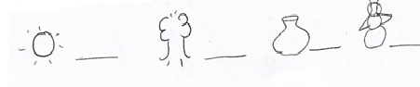

**WK 4**

P1 Join the sound and read.

a s

as ___ __ __

P2 Join the sounds and read.

a t

**P3** Joint the sounds and read.

t __

a s __

n __

**P4** Join the sounds and read.

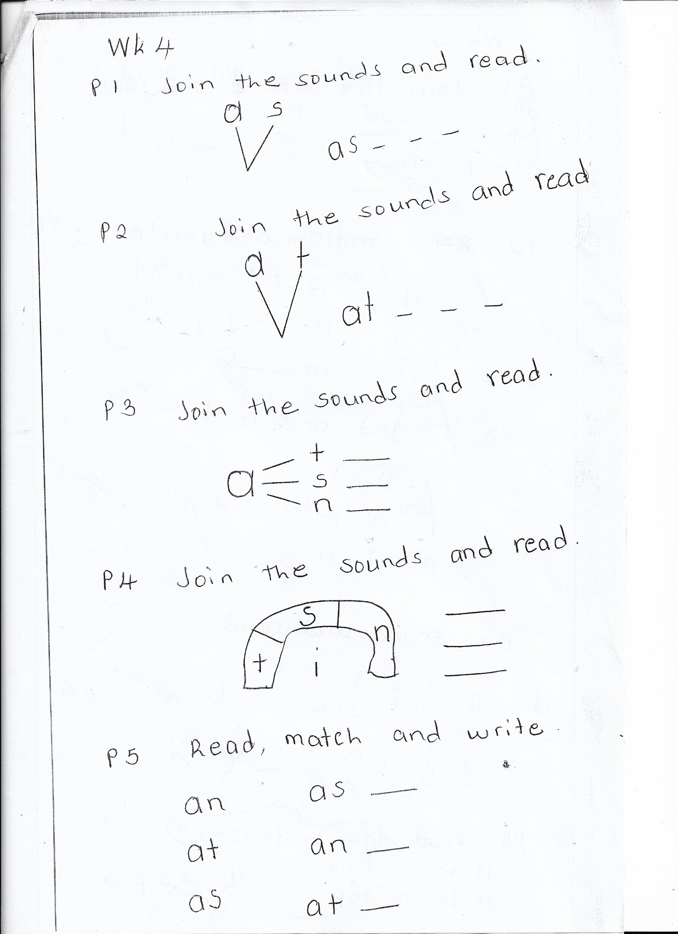

**P5**  Read, match and write

an as ___

at an ___

as at ___

**WK 5**

P1 Joint the sound and red.

t __

i n __

s __

P 2 Read match and write

it is ___

in it ___

is in ___

P3 Sound and read

s - a - t

t - a - p

p - a - n

P4 Sound and read

S - i - t

t - i - n

p - i - n

t - i - n

P5 Read the sentences

It is a tin

It is a tap.

It is a pin.

**WK 6**

PD1 Name the pictures

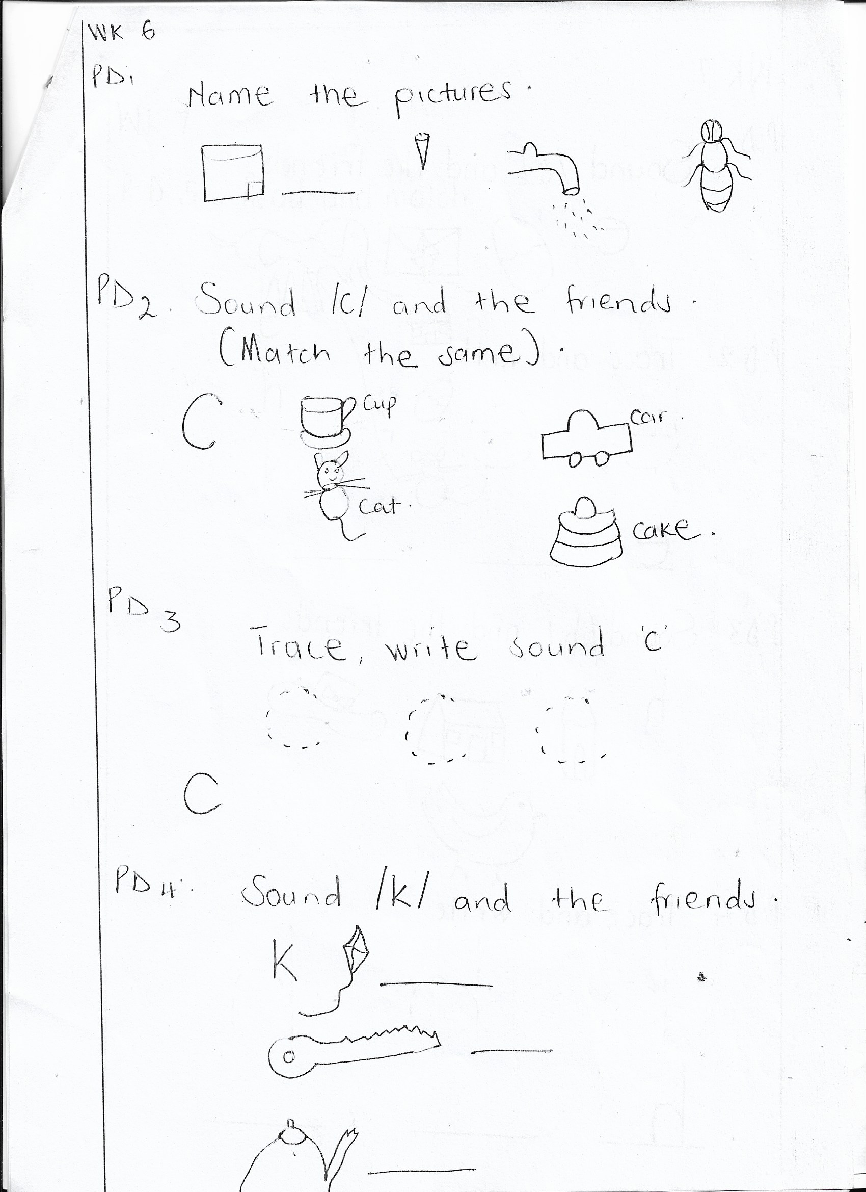

PD 2 Sound /c/ and the friend



PD3 Trace and write C.



PD4 Sound /k/ and the friends



**WK 7**

PD1 Sound /e/ and the friends.

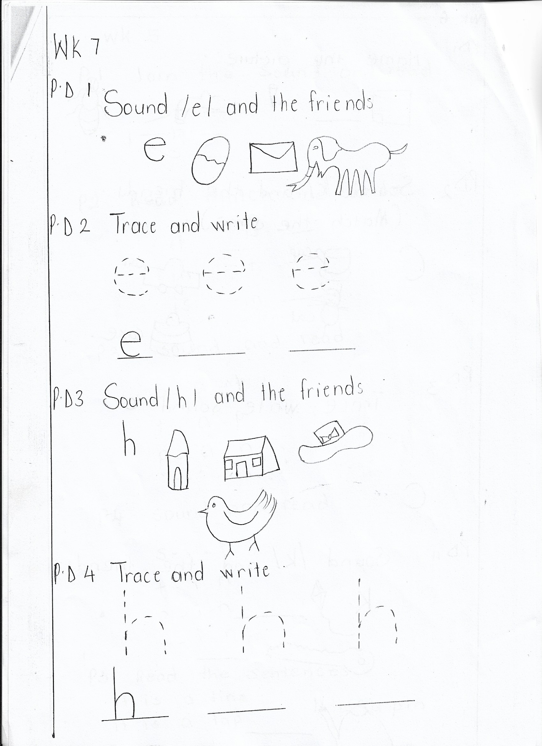

PD 2 Trace and write.



PD 3 Sound /h/ and the friends.

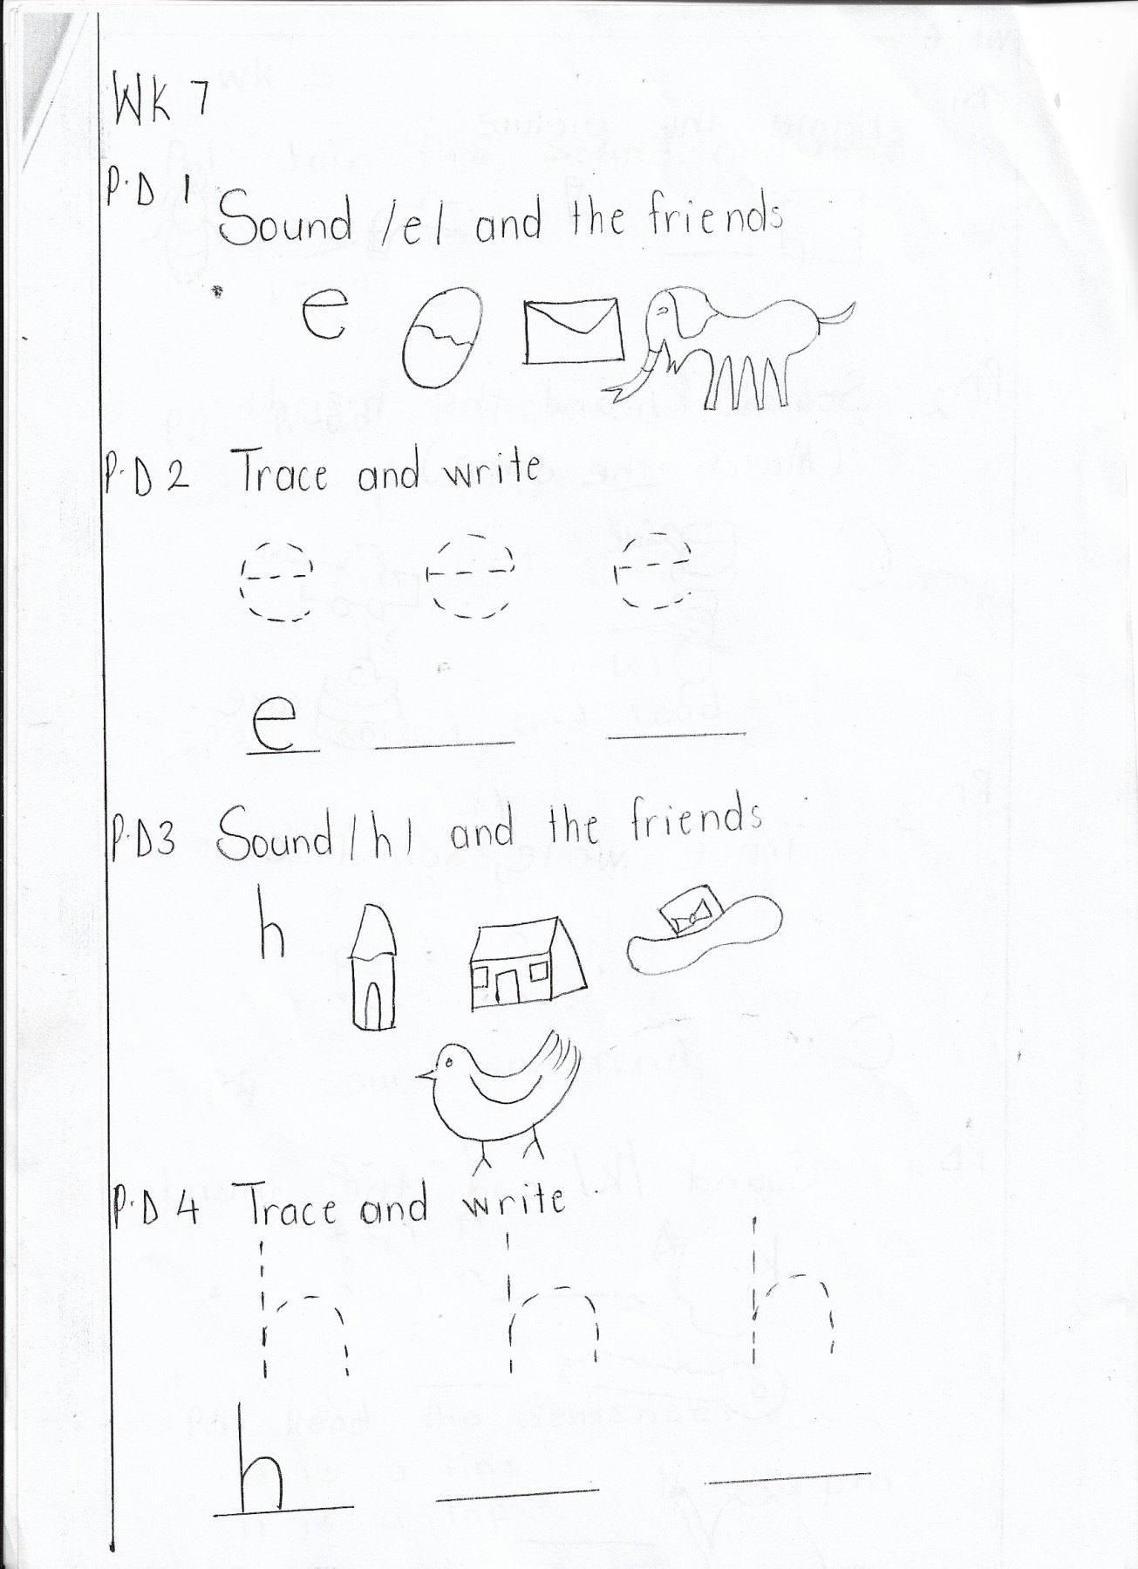

PD 4 Trace and write.



PD 5 Read and match.

